Kenstar KSM55.WN1 Split AC (1.5 Ton, 5 Star Rating, White)
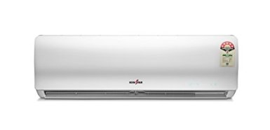
by Kenstar

Price: | 26,490.00 + Delivery charges may apply
 | Inclusive of all taxes
EMI starts at 2,366.01 per month.
Sold and fulfilled by NEXT ONLINE (3.9 out of 5 | 1,556 ratings).
2 offers from 26,490.00
- Installation: For requesting an installation/demo for this product once delivered, please call Kenstar support directly on (STD code) +39404040 and provide the product's model name
- Available in Ahmedabad, Rajkot, Vadodra, Surat, Bangalore, Bhubaneshwar, Chennai, Cochin, Coimbatore, Delhi, Gurgaon, Ghaziabad, Noida, Indore, Jaipur, Kolkata,Lucknow, Nagpur, Patna, Raipur and Zirakpur
- Split AC; 1.5 ton capacity
- Energy Rating: 5 Star
- 1 Year Comprehensive and 4 Years on Compressor
- LCD remote to turn on and off the AC
- Digital display for easier operation

Voltas 185 EY (R) Executive R Split AC (1.5 Ton, 5 Star Rating, Wine Red

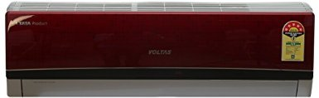
by Voltas

M.R.P.: | 45,990.00
Price: | 34,900.00 + Delivery charges may apply
You Save: | 11,090.00 (24%)
 | Inclusive of all taxes
EMI starts at 3,117.17 per month.

Sold and fulfilled by Electronic Plaza (4.4 out of 5 | 8 ratings).
11 offers from 34,898.00

Color: Wine Red
Installation: For requesting an installation/demo for this product once delivered, please call Voltas support directly on 18004254555 and provide the product's model name
Split AC; 1.5 ton capacity
Energy Rating: 5 Star
1 year warranty on product; 5 years warranty on compressor
Product code: 1.5T 185 EY(R); Rated current: Cooling 6.3 Amps; Rated EER W/W 3.51; Power supply V/Hz/Ph 230 / 50 / 1 phase
Air flow volume: Indoor CMH (850)/780/650/550; Compressor type: High EER rotary

Click to open expanded view

Hyundai HSP33.GO1-QGE Split AC (1 Ton, 3 Star Rating, White)
by Hyundai
3.7 out of 5 stars 3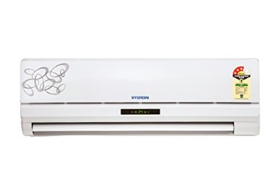 customer reviews

Price: | 31,990.00
Sale: | 19,990.00 + Delivery charges may apply
You Save: | 12,000.00 (38%)
 | Inclusive of all taxes
EMI starts at 1,785.45 per month. Options
In stock.
Sold and fulfilled by Technokart India Limited.
- offers from 19,990.00
Split AC; 1.0 Ton capacity, 3 Star Energy Rating
4 way air deflection, auto swing, auto re-start, de-humidification, turbocool, antibacteria and active carbon filters, Sleep mode, Louver Step Adjust, night glow button on remote
Charges: Any installation/demo is chargeable ranging from Rs 300 to Rs 1500 depending up on the product & brand. We would encourage you to check with the brand when they reach out to you. The process for locking installation call for Hyundai AC is mentioned in the service manual available with the product.
Available in : Delhi, Gurgaon, Noida, Lucknow, Indore, Chandigarh, Kolkata, Hooghly, Guwahati, Mumbai, Thane, Pune, Nasik, Nagpur, Aurangabad, Ahmedabad, Surat, Ludhiana, Hyderabad, Bangalore, Chennai and Cochin
Warranty Details; 1+ 4 Year Compressor Warranty

Voltas 185 CY/A Series Split AC (1.5 Ton, 5 Star Rating, White)
by Voltas
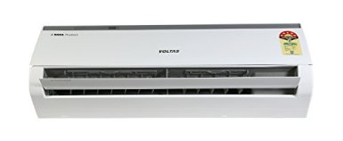

Price: | 45,590.00
Sale: | 33,000.00 FREE Delivery.Details
You Save: | 12,590.00 (28%)
 | Inclusive of all taxes
EMI starts at 2,947.47 per month.
Sold by Cloudtail (4.4 out of 5 | 465,168 ratings) and Fulfilled by Amazon. Gift-wrap available.
- offers from 33,000.00
Installation: For requesting an installation/demo for this product once delivered, please call Voltas support directly on 18004254555 and provide the product's model name
Split AC; 1.5 ton capacity
Energy Rating: 5 Star
1 year warranty on product; 5 years warranty on compressor
Product code: 1.5T 185 CYa; Rated current: Cooling 6.35 Amps; Rated EER W/W 3.51; Power supply V/Hz/Ph 230 / 50 / 1 phase
Air flow volume: Indoor CMH 850; Compressor type: High EER rotary

LG LSA5NP5A L-Nova Plus Split AC (1.5 Ton, 5 Star Rating, White)
by LG
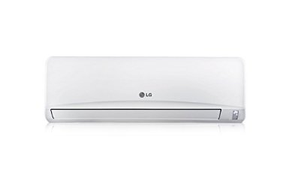
4 out of 5 stars
Price: | 40,990.00
Sale: | 32,990.00 FREE Delivery.Details
You Save: | 8,000.00 (20%)
 | Inclusive of all taxes
EMI starts at 2,946.58 per month.
In stock.
Sold by Cloudtail (4.4 out of 5 | 465,645 ratings) and Fulfilled by Amazon. Gift-wrap available.
11 offers from 32,990.00
Installation: For requesting an installation/demo for this product once delivered, please call LG support directly on 1800-180-9999 , 1800-315-9999 and provide the product's model name
Split AC; 1.5 ton capacity
Energy Rating: 5 Star
2 years warranty on product
The himalaya cool technology provides instant cooling to user by focusing on cooling the living space through smart airflow and 2 times faster vertical air swing
The 3M micro protection filter traps harmful microscopic substances through the strong electrostatic charge on its surface, thus ensuring clean air and enhanced cooling
The monsoon comfort technology provides the right cooling during high humidity and monsoon season

